Kidiwische Connections

Join us at Kidiwische Corner for the first
Spring workshop 2023
and make a beautiful gourd ornament

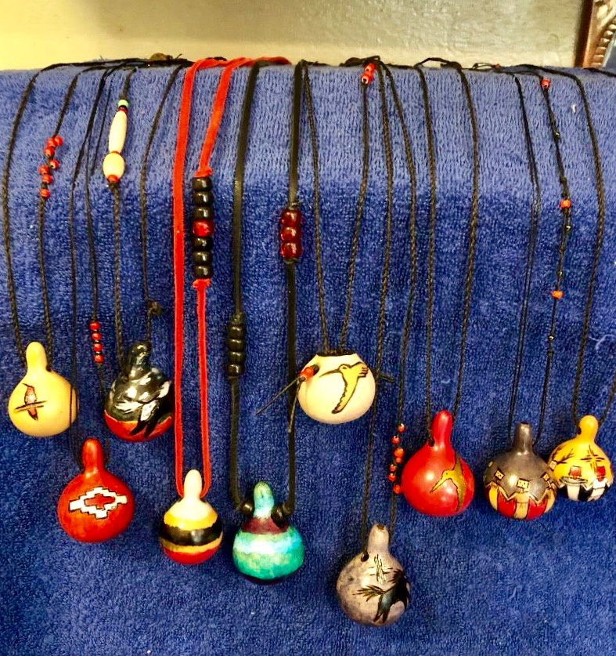

With Neshkinukat Master Artist Nadiya Littlewarrior

Beginning class to find the spirit in your gourd – how to clean, decorate, and enjoy a small gourd ornament or necklace
$40 includes all materials
Bring your sack lunch
Sunday, March 19, 11 – 4
Open to 10 participants, ages 12 and up,
first come first served registration

register at kiwenkikwe@yahoo.com

For information: contact Kat at KatCalls@aol.com.

